

**Gender Pay Gap Report**

**2022 report**

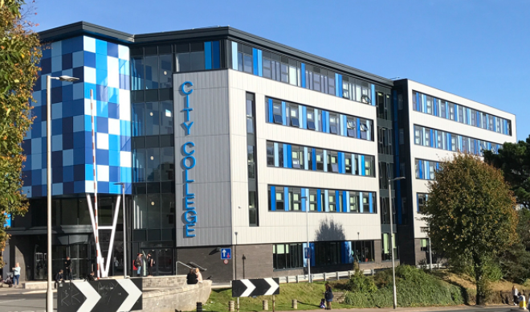

**for City College Plymouth**





**Foreword**

One of the key values of the College is to celebrate diversity and break down barriers to success.

City College Plymouth is therefore committed to equality, diversity and inclusion and is committed to reducing barriers and offering fair opportunity to all staff and students. Part of this commitment is to ensure that we provide the opportunities to all regardless of gender or any other reason that cannot be justified in job related terms.

The College is committed to publishing its gender pay gap data together with the promise that we will work to narrow any gaps. In an increasingly diverse world, we recognise that we have the responsibility of ensuring that our staff feel valued, included and rewarded on an equal platform.

The College takes pride in its commitment to equality and diversity, and continues to review all aspects of working and learning to ensure that we celebrate and promote equality, diversity and values for life and work in modern British society through our activities and events.

**Background**

The Equality and Human Rights Commission defines the difference between equal pay and the gender pay gap as follows:

1. **Equal pay** means that men and women in the same employment performing equal work must receive equal pay, as set out in the Equality Act 2010.
2. The **gender pay gap** is a measure of the difference between men’s and women’s average earnings across an organisation or the labour market. It is expressed as a percentage of men’s earnings.

In accordance with the Government’s Public Sector Employer Consultation, the College captured its gender pay data as a snapshot on 5 April 2017. The College publishes its gender pay gap report within its Equality and Diversity report in February of each year.

The data where appropriate has been broken down by both full-time and part-time staff, this has been done to aid our understanding and also to help identify if there are issues of concern within the part-time staff population.

**The Headlines**

**The overall difference between men and women:**

|  |  |  |  |
| --- | --- | --- | --- |
|  | *National Average*  *(ONS for 2020)* | *Education sector* | *City College Plymouth* |
| Mean gender pay gap | 14.6% | 17.1% | 10.69% |
| Median gender pay gap | 15.25% | 24.6% | 17.27% |

**Gender distribution at City College Plymouth, across 4 quartiles:**

* Lower quartile = 22.22% male and 77.78% female
* Lower middle quartile = 27.95% male and 72.05% female
* Upper middle quartile = 45.96% male and 54.04% female
* Upper quartile = 43.48% male and 56.82 % female



|  |  |  |
| --- | --- | --- |
|  | *City College Plymouth*  *(2020 data)* | *City College Plymouth*  *(2021 data)* |
| Mean gender pay gap | 9.62% | 10.69% |
| Median gender pay gap | 15.69% | 17.27% |

**Gender Pay Gap Summary**

Our analysis shows that the overall difference between men and women’s earnings is 10.69% (mean) or 17.27% (median) based on the hourly rates of pay at the snapshot date of 5 April 2020. Meaning that, on average, female employees are paid less than male employees. It is important to remember that the calculation behind the gender pay gap is not the same as equal pay.

We meet our legal duties under the Equality Act 2010 to promote equality by:

* driving the agenda at the highest level
* developing and raising awareness across the organisation
* sharing good practice
* working with learners, staff and external partners to address barriers faced by particular groups to allow full participation
* monitoring, measuring and evaluating the impact of Equality and Diversity policies, and practice.

The College is committed to being an inclusive workforce and recognises that the Senior Leadership Team needs to represent females at the top of the organisation. Gender at the top of the organisation is equally represented. Where pay gaps exist it is due to the individual nature and level of responsibility for each individual role.

There is good representation of female staff in management positions at the College with over half of the College Leadership Team (CLT) being female. Where roles within the CLT structure are directly comparable the posts are graded the same, and are reflective of the nature of the organisation and the different roles’ direct impact on student achievement and financial health.

The results from the quartile percentages arise due to a number of factors: The majority of our lower paid employees are in roles that are predominantly assistant roles which involve fewer skills, demand less experience and require lower level qualifications. Often these roles are used as an entry to other roles in the workplace and are attractive to those who are returning to work following a career break.

In reviewing the data it is important that we look to increase the number of men in these support roles, the roles typically filled by women – nursery assistants, customer services assistants, general administration roles and learning support assistants.

**Work so far**

We aim to create a culture and ethos of mutual respect, understanding and tolerance within a friendly, harmonious and safe learning environment. The Equality and Diversity Committee and Corporation receive termly progress updates generated from monitoring systems that report on course and College-wide equality performance.

As part of its Public Sector Duty, the College publishes its Equality and Diversity Annual Report, which includes progress towards equality objectives. There is a Disability Forum with learner representatives, a well-established chaplaincy team and support groups for students who are parents-to-be/young parents, students who are young carers and students who may be experiencing mental ill health.

We fulfil our commitment by:

* embedding equality and diversity within all our practices
* advancing equality and diversity by tackling all forms of discrimination
* celebrating diversity and difference
* Seeking to educate staff, students and the community to both foster good relations and recognise the benefits of a diverse community.
* Having ‘Family Friendly’ policies and procedures in place which are known to all staff which encourages both male and female employees to discuss flexible working arrangements which will not inhibit career progression.

The Mandatory Gender Pay Gap Reporting – Public Sector Employers Government Consultation document also highlights the requirement for public authorities to publish the difference between mean and median bonus payments paid to men and women. The College does not operate a bonus scheme and therefore no data is available for this metric.

Under the law, men and women must receive equal pay for:

* the same or broadly similar work;
* work rated as equivalent under a job evaluation scheme; or
* work of equal value.

**What's next?**

The College will develop a Gender Pay Gap Action Plan, subject to consultation, and will continue to monitor this to address any differential in pay between men and women in the organisation

This information will be updated annually with data from the ‘snapshot’ date each year.

Our aim is to close the gap year on year and to do this we are committed to:

* closing the gap of our salary scales towards the bottom of our harmonised pay scales.
* A commitment to being a Living Wage employer which will increase the hourly rates of our lower scale roles.
* Promoting our female role models internally and externally
* Robust and consistently applied policies and procedures relating to equality, as well as rigorous over sight by the HR function at the College to ensure there is no gender bias in any recruitment and selection or career promotion process.
* Improving opportunities for flexible working through the Worklife Balance and Special Leave arrangements
* Taking gender into consideration when identifying succession planning
* Ensuring that development and learning opportunities are available
* Making the lower salary roles more attractive to men, by using male role models.

**Conclusion**

The College is confident that men and women are paid equally for doing the equivalent or same job.

It is important to note that the College is committed to a fair and transparent recruitment and selection process, that roles, new and existing are financially rewarded based on the needs of the business and not on gender.

None of these initiatives will, of itself, remove the gender pay gap - and it may be several years before some have any impact at all. In the meantime, City College Plymouth is committed to reporting on an annual basis on what it is doing to reduce the gender pay gap and the progress that it is making.

There are roles within the College which are predominantly filled by female staff, and these roles are traditionally undertaken by women. However, the College seeks to attract and retain individuals from all backgrounds to undertake these fulfilling roles.