INTERNATIONAL FOUNDATION COURSE - SCIENCE

This course is designed to introduce students to the key aspects of science (biology, chemistry and physics). It will equip students with vital knowledge and skills to enable them to flourish academically and personally.

COURSE DETAILS
- Approximately 25 hours per week
- Starts in January of each year
- Finishes beginning of July
- Class sizes of 15 students
- Be part of the UK culture
- Be in a class of different nationalities

PROGRESSION AND MAIN BENEFITS
- Experienced and friendly staff will offer the necessary support and guidance during the course
- Practical sessions throughout the course
- A dedicated international team who can also support you with your welfare
- You will be able to progress to universities in the UK and other countries
- An IELTs test will be organised during the course
- Extra curricular activities available to attend

CORE SUBJECTS
- English for Academic Purposes
- Academic Skills
- IT
- General Maths
- Advanced Maths
.

BIOLOGY
To develop the student's knowledge and application of Biology to scientific and technology problems. Students will develop knowledge on cells, tissues and the organ. Plus other topic areas

CHEMISTRY
To develop the student's knowledge and application of Chemistry to scientific and technology problems. Students will look into objectivity, inventiveness and precision including atomic mass, ionisation, electronegativity and atoms. Plus other topic areas

PHYSICS
To develop the student's knowledge and application of Physics to scientific and technology problems. To prepare students for technology studies including laws of motion, renewable energy, waves and nuclear physics. The student will look at the environmental impact of physics and be prepared to study level 4 in physics or engineering.

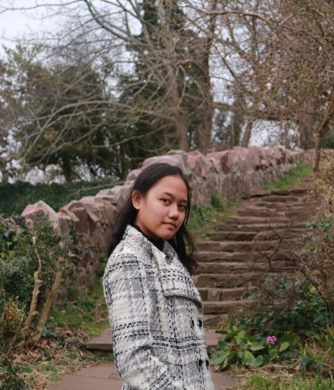
Studying in City College Plymouth is fascinating. Teachers always help us throughout our studies here. Socializing with friends whose nationalities are not the same as me broadened my knowledge about their culture and helped me improve my English. I learnt how to solve problems by myself and was not being spoiled. Being an international student is a new experience for me, and City College Plymouth and PDVL make it such a great experience!
Fransisca Yohanna

