PREMIER INTERNATIONAL YEAR 1 - BUSINESS

This course is designed to introduce students to the key aspects of business (level 3 and 4). It will equip students with vital knowledge and skills to enable them to flourish academically and personally within business.

COURSE DETAILS
- Approximately 16 hours per week
- Starts in September of each year
- Completion end of May
- Class sizes of 15 students
- Be part of the UK culture
- Be in a class of different nationalities

PROGRESSION AND MAIN BENEFITS
- Experienced and friendly staff will offer the necessary support and guidance during the course
- A dedicated international team who can also support you with your welfare
- You will be able to progress to universities in the UK
- An IELTs test will be organised during the course
- Extra curricular activities available to attend
SUBJECTS
- Exploring Business (level 3)
This is an introductory module into the worlds of business

- Business Resources (level 3)
This module looks at 3 main resources – human, finance and equipment
- Teambuilding in Business (level 3)
This module looks at how different teams work depending on the type of people in the team.
- English for Academic Purposes (level 4)
This module will help you improve your english and prepare you for your IELTs
- Organisational Behaviour
This modules look into understanding how organisations and employees manage and adapt behaviour.
- Economic Environment for Business This module introduces you to the national and international economic environment and considers different factors that influence decisions.
- Business Finance
This modules looks into how to prepare and interpret financial information and
use basic financial tools for decision making purposes.
- Managing Knowledge and Information
This module looks into knowledge management from a human resource, information systems and from a planning and decision making process.
- Marketing
This module looks at the marketing principles and concepts and how you apply it in a business.

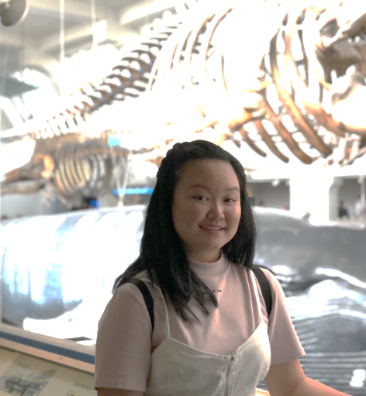
It is an honor that I can join this amazing program. I never thought that studying abroad will be this much fun. Meeting new people in a new environment has brought a lot of meaning to me. All the international staff are amazing and helpful with international students. As well as the host family that has been treating us nicely. It such a pleasure to experience living in a local's house with a different culture that brings a lifetime experience. A new challenge that we are facing everyday is valuable and worth it at the end of the day.
Vanya Natania

